# 1.INTRODUCTION

1.1 OVERVIEW

To analyze identified trends and patterns in the air transportation network, providing valuable insights into the state of the industry. The information can be used to optimize routes, improve operational efficiency, and enhance customer experience.

1.2 PURPOSE

Help the managements to make informed decisions related to business growth, investment, capacity planning and infrastructure development

2.PROBLEM DEFINITION & DESIGN THINKING

2.1 EMPATHY MAP

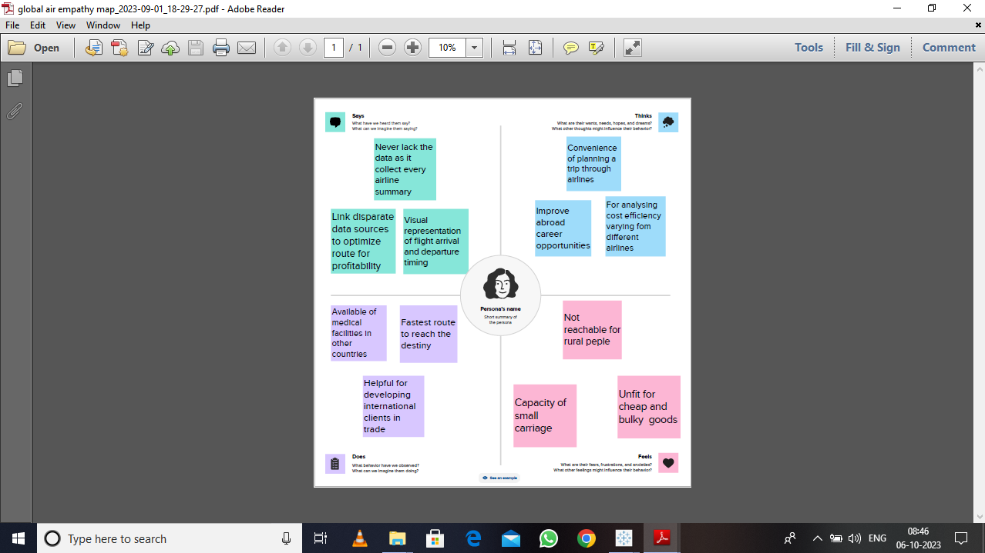

2.2 IDEATION AND BRAINSTROMING MAP

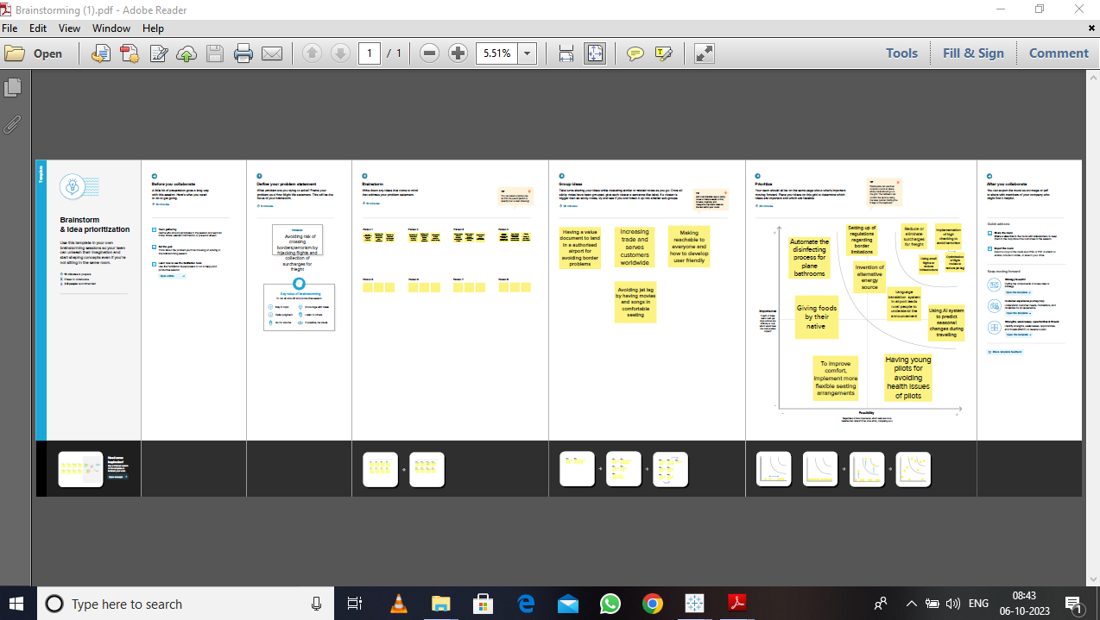

3.RESULT

3.1 DASHBOARD 1

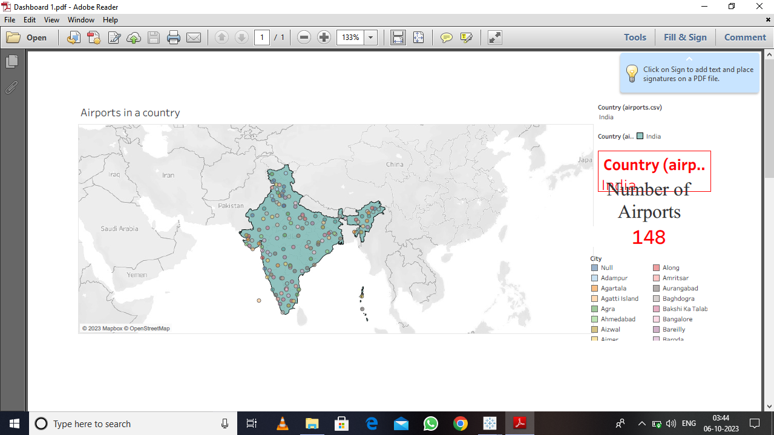

3.2 DASHBOARD 2

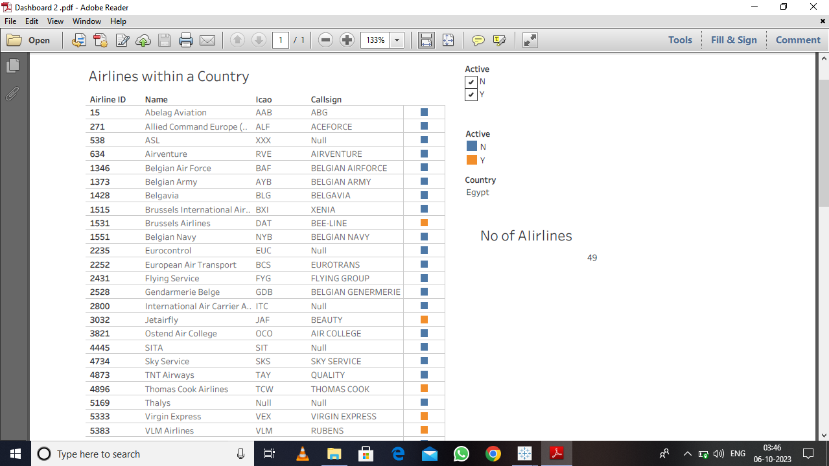

3.3DASHBOARD3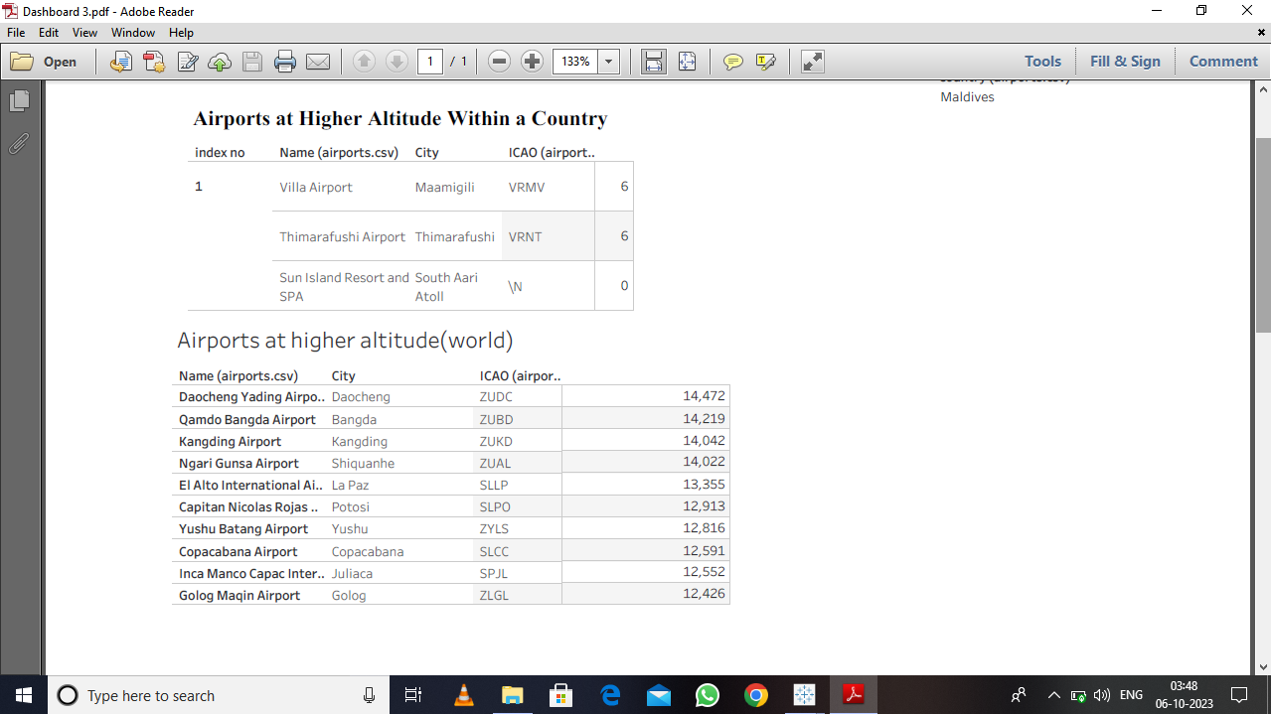

3.4 DASHBOARD 4

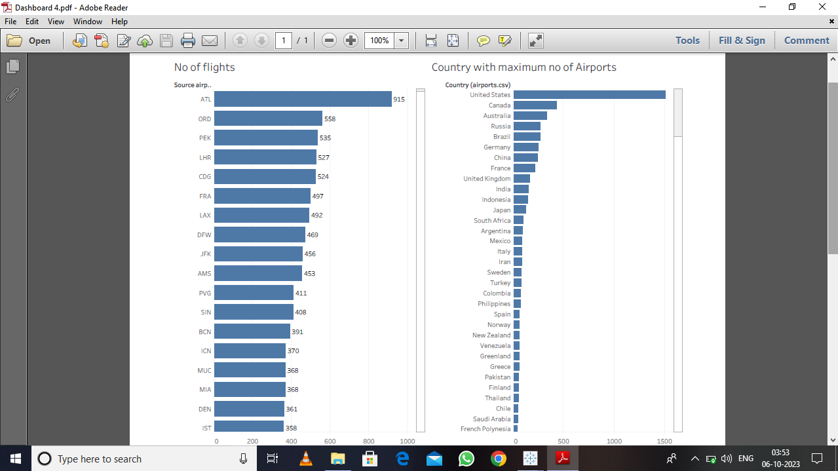

3.5. STORY

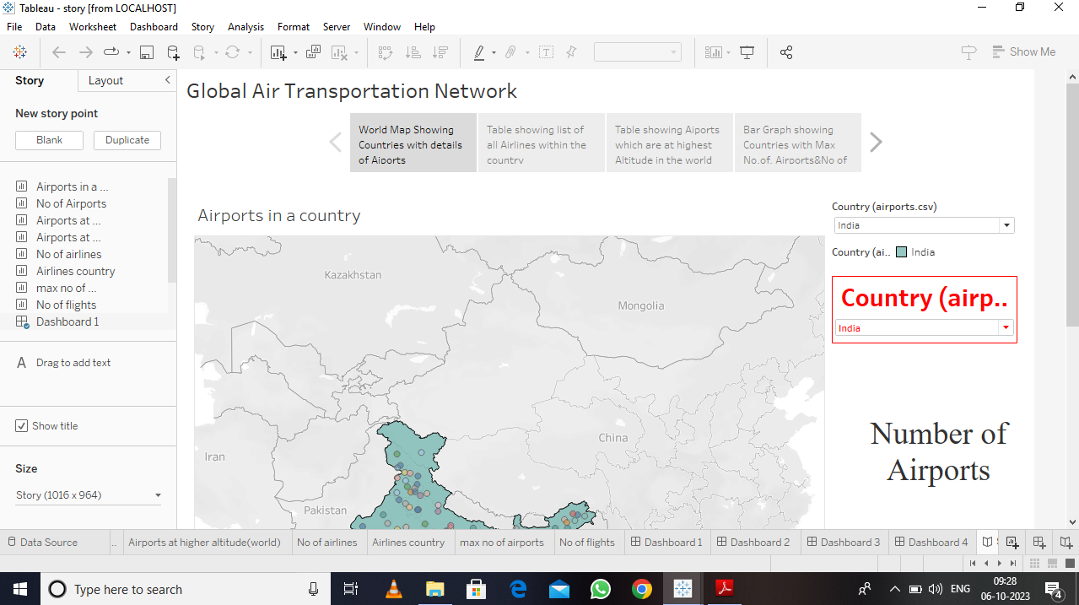

4.ADVANTAGES& DISADVANTAGES

4.1 ADVANTAGES

* The development of air transport networks is more efficient, safe and sustainable.
* Making air travel more accessible, affordable and eco-friendly.
* Investors to identify geographic areas for investment in the aviation industry.

4.2 DISADVANTAGES

* Runs on a timetable not eligible in critical situations.
* Varying quality of service depending on management.
* Vulnerable to season and weather impacts.

5.APPLICATIONS

Enables them to make fast, data driven decisions on the spot and identify invaluable operational savings in pandemic situations.

6.CONCLUSION

It can be harnessed to improve our operational excellence across the board from customer bookings to aircraft maintenance scheduling. Finding and unlocking the insights hidden in our data allows us to continually refine business processes and achieve clockwork operation at scale, which is key to long term success in the modern aviation sector.

7.FUTURE SCOPE

Data needs to be tailored to their specific requirements. Data must be highly accessible even when out of the office to help the executives to make decisions from anywhere.